

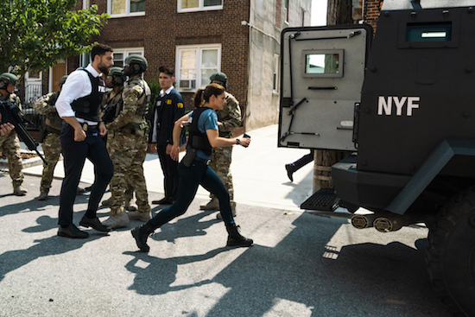

**Critical Incident Response Group**